Introduction:

In the realm of Digital Logic Design (DLD), a digital clock serves as a sophisticated system that employs electronic components to showcase time in a digital format. Typically, these clocks integrate an array of digital logic elements, including counters, decoders, and display drivers. The presentation of time often involves numerical digits or a 7-segment display, indicating hours, minutes, and seconds.

Our semester project involves a compelling fusion of two integral components: the widely used 555 timer and the versatile 4026 counter. This amalgamation results in the creation of a Digital Clock, where the 555 timer functions as the pulsating core, generating precise clock pulses to ensure accurate timekeeping. Complementing this, the 4026 counter comes into play, seamlessly managing the count and orchestrating the display through a seven-segment configuration.

This project not only serves as a platform for hands-on learning but also underscores the practical application of the theoretical concepts and skills acquired throughout the course. The 555 timer acts as the rhythmic heartbeat, maintaining temporal accuracy, while the 4026 counter diligently keeps track of the count and translates it into a visually comprehensible time display. This digital clock not only encapsulates our understanding of digital logic but also serves as a tangible implementation of our acquired knowledge and skills.

Block Diagram:

The Block Diagram of the digital clock is given below:

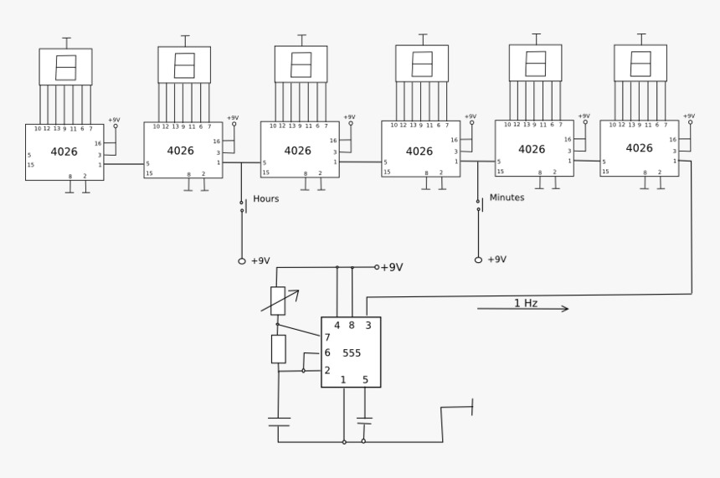

Working:

The circuit initiation involves configuring the 555 timer IC as a monostable Multivibrator, generating clock pulses at one-second intervals. The output from the 555 timer IC is then connected to pin 1 of the IC 4026, which functions as a seven-segment display decade counter responsible for driving a 7-segment display with the incoming clock pulses. These clock pulses are derived from the monostable multivibrator and directed into pin 1 of the initial IC 4026.

Upon the circuit's initial power-up, the seven segments will prominently display "00:00:00". As the 555 timer produces a high pulse from pin 3 in response to a negative trigger, this signal is directed to the first IC, prompting it to increment its count with each clock cycle. Consequently, the seven segments display numeric values ranging from 1 to 9. Upon reaching a count of 10, a high-to-low signal is generated from pin 5 of the first IC, signaling the completion of ten increments. This signal is then connected to the clock pin of the subsequent 4026 IC.

Upon completing ten counts, the high-to-low signal at pin 5 provides a single clock pulse input to the second IC, facilitating an increment in the corresponding seven-segment value. To maintain the digital clock's accuracy, the second IC requires resetting when it reaches the number 6, allowing for a second count up to "59". This function is achieved through the incorporation of an IC 7411 (Three-input AND Gate).

Similarly, the fourth IC oversees the counting from 0 to 6, subsequently leading to an increment in the value of the fifth IC. This systematic process governs the seconds and minutes displayed on the clock. To manage the hours, the fifth and sixth ICs must be reset when the numeric value reaches "23". To fulfill this requirement, an additional three-input AND gate is incorporated into the circuit, ensuring the precision and reliability of the digital clock's timekeeping capabilities.

The clock will reset the counter once it becomes equivalent to a specific condition provided by us. There will be 3 conditions needed for the clock to reset and work properly and efficiently eg. Seconds and minutes will run till 59 and it will reset to 00 once the condition is fulfilled. The hours counter respectively will be set to 00:00:00 after 23:59:59.
Their working is explained below:

- Seconds and minutes: The logic is the same for both counters. We will connect the E, F, and G Diodes of the 7 – Segment Display to a 3-input AND gate. Now by implementing this condition such that when E, F, and G Diodes turn on, it will be sent to the AND gate as its input and the output will be high, sending the signal to the reset pin of the respective 4026 decade counter IC which is pin no. 15. This phenomenon will remain same for the minutes counter.
- Hours: The logic for the hours counter is almost the same except we will connect G Diode of the 1 display and E, F of the second display to the AND gate which will turn high when all of those diodes/inputs are high resulting in a signal that will be sent to the reset pin no. 15 of the 4026 IC. Therefore, the counter will reset and start from 00:00:00.

Components:

The components utilized in our project are detailed as follows:

1. 555 Timer:
Function: The 555 timer serves as an astable multivibrator, oscillating between its two stable states to generate a continuous stream of clock pulses.
Connection: Configured in astable mode, the 555 timer's output (pin 3) generates clock pulses that act as the foundational time base for the digital clock.

2. IC 4026:
- Function: The 4026 is a 7-segment counter equipped with a built-in decoder. It tallies the incoming clock pulses and produces the corresponding Binary Coded Decimal (BCD) values for each digit.
Connection: The clock input (pin 1) of the 4026 is linked to the output of the 555 timer, while the Q0 to Q9 outputs (pins 2-11) are connected to the respective segments of the 7-segment display.

3. IC 7411 (Three-input AND Gate):
Function: Employed for controlling the reset of the 4026 counter based on specific conditions.
Connection: Input connections to the AND gate (pins 1, 2, 3) are established with designated outputs of the 4026 counter. The AND gate's output is then connected to the reset input (pin 15) of the 4026.

4. 7-Segment Common Cathode Display:
Function: Displays numerical digits ranging from 0 to 9, depending on the BCD values received from the 4026 counter.
Connection: The common cathode of the display is linked to the ground, with segments connected to the Q0 to Q9 outputs of the 4026.

5. 1.5uF Capacitor:
Function: An integral part of the timing circuit within the 555 astable multivibrator, determining the frequency of the clock pulses.
Connection: The capacitor is positioned between pins 2 and 6 of the 555 timer.

6. 470 Ω and 470 KΩ Resistors:
Function: Essential components of the timing circuit within the 555 timer, define the frequency of the clock pulses.
Connection: The 470-ohm resistor is connected between pins 7 and 8 of the 555 timer, while the 470-kilohm resistor is interlinked between pins 6 and 7 of the 555 timer.

7. 9V Battery:
Function: Serves as the power supply for the entire circuit.
Connection: The positive and negative terminals of the battery are appropriately linked to power and ground points on the circuit.
S

Simulation:

The Simulation of one of the total 6 counters is attached below ( screenshot ):

This one counter will add up to make up a total of 6 counters for a digital clock to work effectively in the following way:

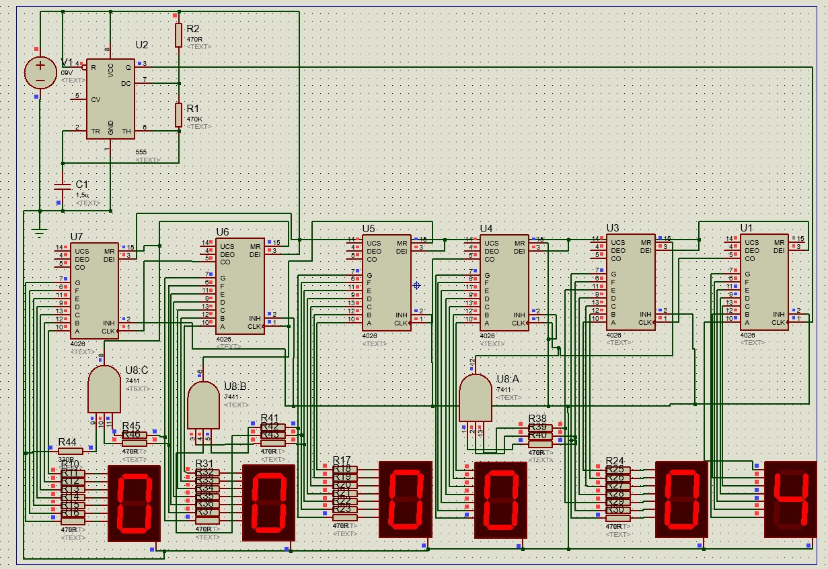

Pictures of our Project:

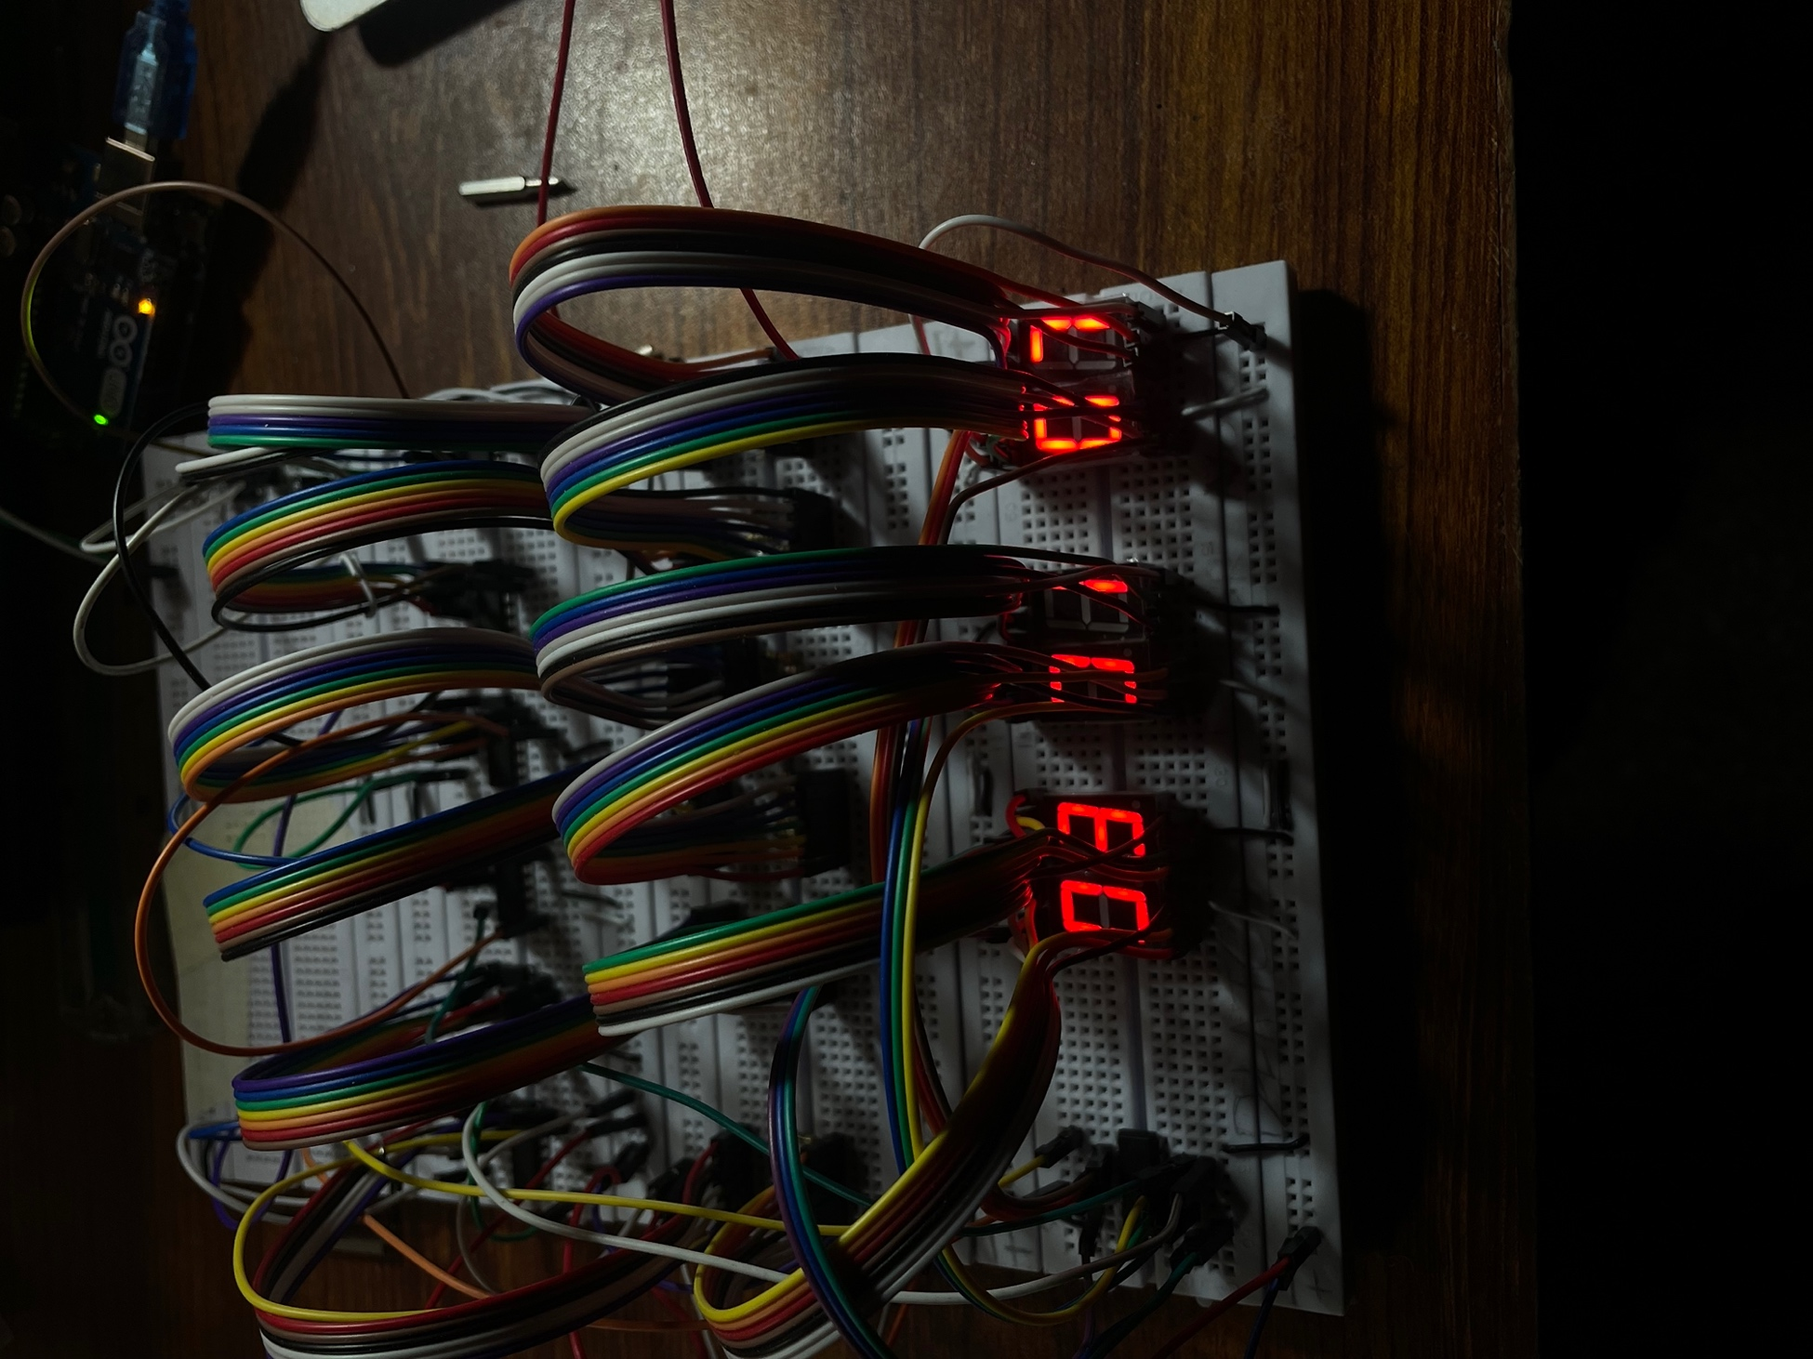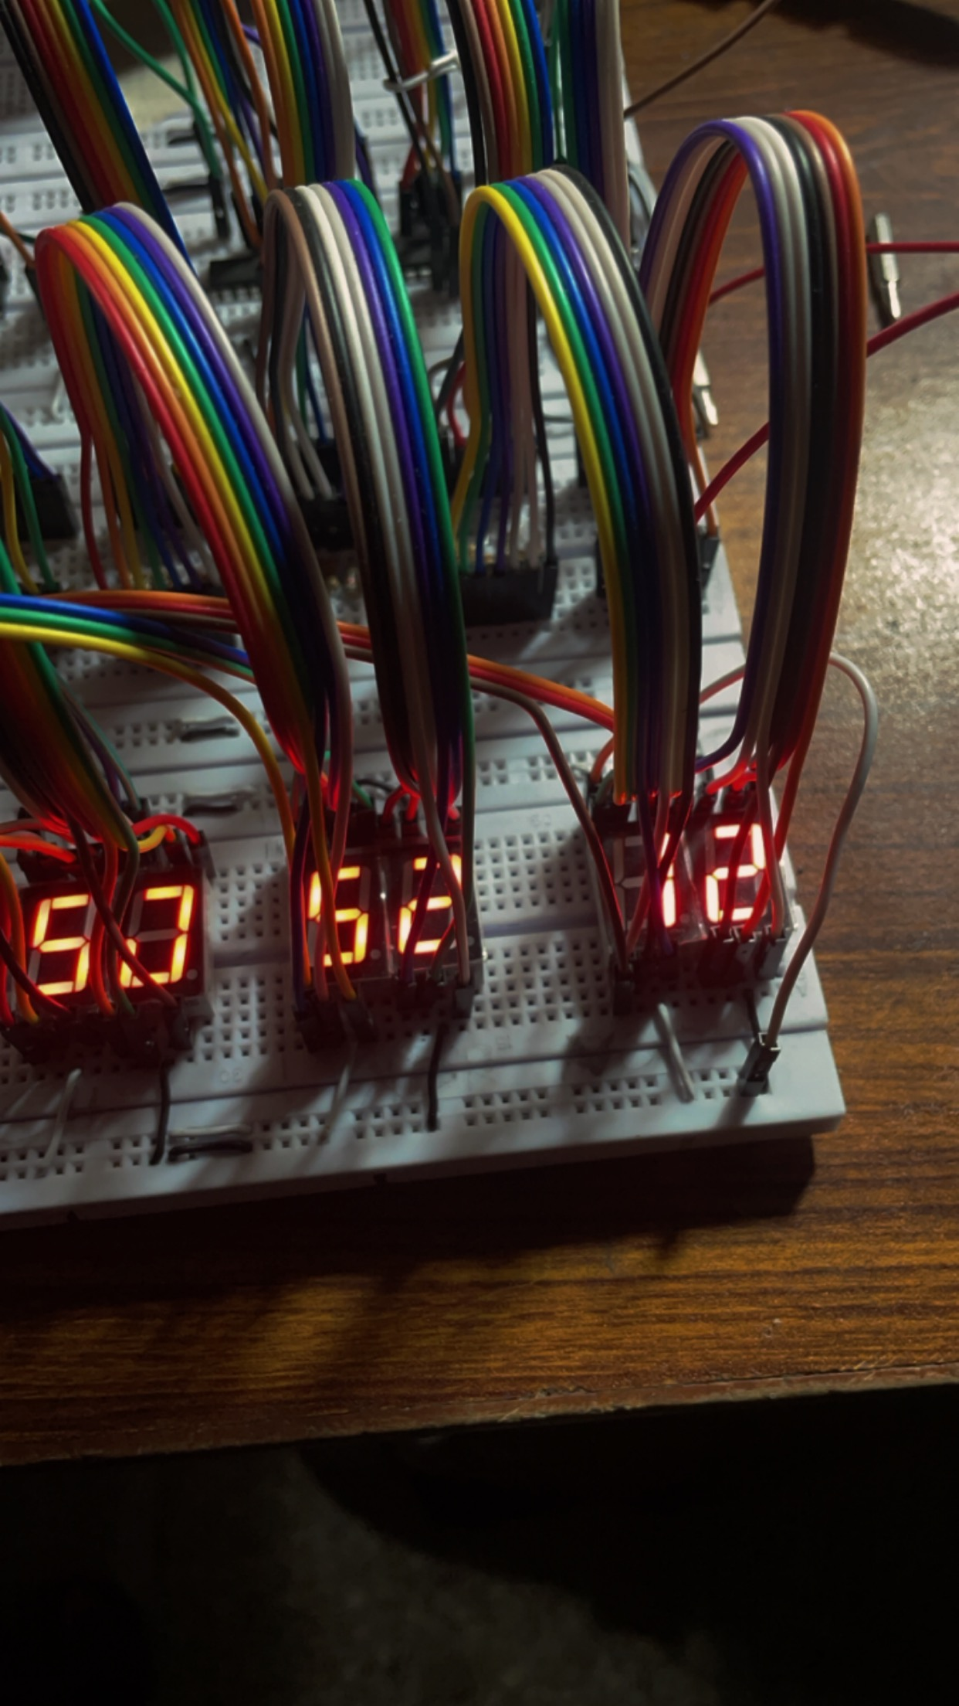

Time Frame:

- 30 December:
Selection of our project.

- 15 December:
We submitted our Half implementation and gave viva.

- 22 December:
During the half implementation, ma’am recommended some changes to be made to our project. So, we presented our updated project with the following recommendations.

- 29 December:
Report (half).

- 14 January:
Final Submission and Viva.

Conclusion:

To recap, the 555 timer produces clock pulses, the 4026 counter enumerates and deciphers these pulses, the AND gate oversees the reset function, and the 7-segment display graphically illustrates the digits. The frequency of the clock pulses is established by the capacitor and resistors within the timing circuit of the 555 timer, while the entire circuit is powered by the 9V battery.

This amalgamation of components forms a combinational circuit, operating on the principles of logical design. The resultant digital clock showcases the time on 7-segment displays, facilitated by the functionality of the timer IC 555.

